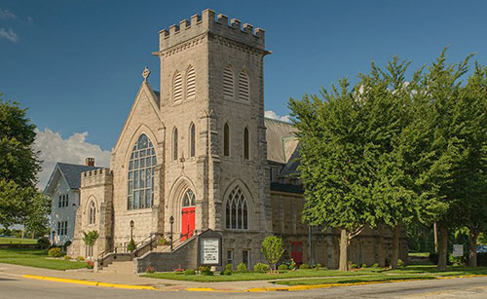
Parish Profile

St. Paul’s Episcopal Church
298 S. Harrison Avenue
Kankakee, IL 60901
815-932-6611

December of 2025

Mission of the Church

“Seeking to Grow in Christ . . . Sharing, reaching out and making God’s presence known to all.”

Our mission at St. Paul’s focuses on several different aspects of the Christian experience, each important in its own way.
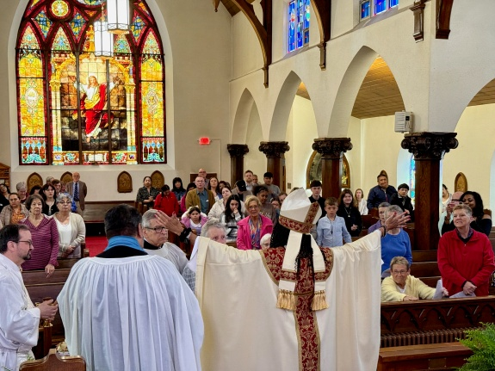
Our primary goal is to grow in our own Christian faith, striving to see this goal in all that we do.
This growth comes from a variety of sources, both as a church and as individuals. Worship, fellowship, prayer, and Bible study are all ways we can draw ourselves closer to Christ.

However, our duties as Christians don’t end with ourselves. We believe strongly in the importance of reaching out to others as we are called to do by Jesus – “to feed the hungry, give drink to the thirsty, clothe the nakes, and give support to the sick” (Matthew 25:35-40). Everything we have in life is a gift from God, and each of our gifts – whether they be of time, talents or earthly possessions – we have to share with others.

Who Are We


At St. Paul’s, we come together to worship God in community, united by grace and guided by love. We joyfully welcome those who seek connection through worship and fellowship. As an open and affirming congregation, we warmly invite those who want to worship with us and become a cherished member of our church family. As parishioners, we are eager to assist the needs of not only our church, but also our future rector.

St. Paul’s Episcopal Church, located in Kankakee, Illinois, serves not only the city but also Episcopalians in neighboring towns and counties. The church building includes an attached rectory, and the parish has been a steadfast presence since its founding in 1863. Remarkably, it has had only six full-time priests over the past 75 years, reflecting a legacy of stable and dedicated leadership.

St. Paul’s is committed to meeting the spiritual needs of both parishioners and the wider community. Currently, we offer a 9:30 a.m., Sunday Worship which is bilingual, led by a supply priest or lay minister, with music.

It is our goal to return to two Sunday Eucharist services, the first being at 8:00 a.m. and a second at 10:15 a.m. We view each Sunday having lay translators and lesson readers help foster inclusivity and understanding. Our organist and choirmaster lead the choir and congregation in singing hymns in both English and Spanish. We provide English and Spanish hymnals, along with bilingual service booklets, to ensure everyone can participate fully. We envision the 8:00 a.m. service to remain a quiet, contemplative offering in English, without music.

The congregation at St. Paul’s reflects the diversity of the Kankakee community. Our parishioners represent the cultural and ethnic backgrounds, racial identities, and gender expressions in and around Kankakee County. Our community is enriched by the unique experiences and perspectives each person brings, and we give thanks to God for this beautiful tapestry of humanity.

Our Diocese

The Episcopal Diocese of Chicago offers a dynamic and diverse landscape for ministry, stretching across northern Illinois—from the shores of Lake Michigan to the banks of the Mississippi River, from the Wisconsin border to Peoria and beyond. With 114 congregations in urban, suburban, and rural communities, the diocese offers a rich variety of contexts in which to live out one’s calling.
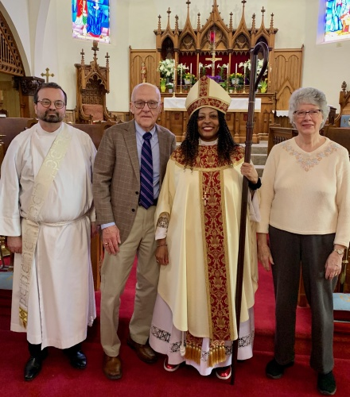
Clergy in new calls are supported through the Fresh Start program, designed to ease transitions, and foster strong foundations and collegial relationships. Opportunities for connection and renewal, including the annual Clergy Retreat and the Chrism Mass, bring clergy together for worship, fellowship, and shared purpose. The diocese invests in leadership development through the College for Congregational Development, lay leadership programs, and the Certified Church Treasurer initiative—ensuring that clergy and laity are equipped to lead thriving, resilient congregations.
Under the leadership of the Right Reverend Paula E. Clark, the diocese is embracing a strategic planning process that uses data to guide mission focus and resource allocation. Episcopal Charities and diocesan commissions, committees, and taskforces are actively engaged in outreach, education, and advocacy. The diocese is consciously moving toward becoming a more adaptive environment for ministry.
To apply for this position, please complete The Clergy Information Form for Transitions from the Diocesan website: episcopalchicago.wufoo.com/forms/m1poxgz40cwsj2w/

Questions about this position should be directed to The Reverend Canon Andrea Mysen, Canon to the Ordinary: amysen@episcopalchicago.org.

Our History

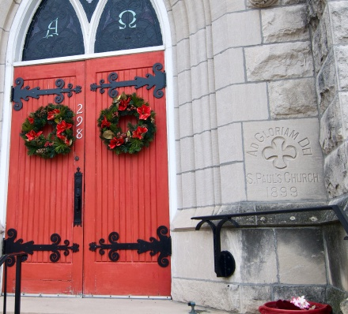
The history of St. Paul’s begins with the organization of the parish at its first location in July of 1863. The group did not even have a church building yet, but met on the third floor of the Exchange Block Building at the Northeast Corner of East Avenue and Station Street, known later as the Commercial Hotel. St. Paul’s first church was built at the corner of Schuyler and Merchant between the years 1864 and 1865, at the cost of $8,000.

The second building, however – and the same beautiful church used by the parish today – was purchased by the parish in March of 1899. Construction was completed by early 1900, after which the Kankakee Gazette devoted half a page to praising the new building.

The church has had a tumultuous history, rising and falling with the economic climate of the city itself. The mid-1900s brought St. Paul’s immense growth and spiritual renewal, with a booming parish and increased mission work. The church building itself enjoyed revisions during this time; a new pipe organ and wooden ceiling were installed in 1952 and are still enjoyed by our congregation today.

During this time, St. Paul’s flourished under the tenure of several beloved ministers. Father James Parker served as rector of St. Paul’s for twenty-eight years, and became well-known all throughout the Diocese of Chicago as a vigorous and energetic priest who had a strong vision for the missions of the church. The young Reverend Robert L’Homme came to the church in the late 1960s, and was quickly commended for his devotion to building the parish’s strong youth program.

However, shifting demographics of the community had a great impact on the parish during the 1980s, and the church saw not only a gradual decrease in overall number, but had many members touched by the closing of local firms and the rising unemployment rate. The youth group fell into a slump when fewer young people remained to replace those growing up. This downturn would continue to hit St. Paul’s well in to the late 1990s.

Thankfully the future looks brighter than ever for the parish. A previous Rector, Father Anchan, led the parish to active outreach to the Latino community in the area. Since 2015, the parish created an active program of home visits by the Rector, attraction of Latino youth to Sunday School and to serving as acolytes, and development of a bi-lingual Eucharist service each Sunday.

Our Facilities

Our church home is rooted in tradition and open to renewal. St. Paul’s Episcopal Church stands proudly on a solid foundation—both spiritually and structurally. The church campus includes a spacious nave and chancel for worship, a large parish hall for gatherings and events, staff offices to support church operations, several multi-purpose rooms for classes, meetings, and outreach, a fully equipped kitchen for parish meals and hospitality, an attached rectory, and a vacant lot that provides open space for future possibilities.
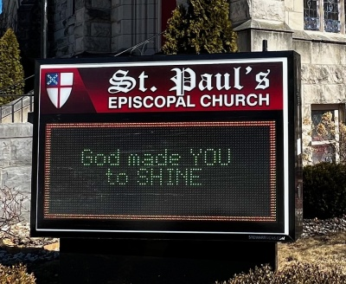
As we continue to enhance accessibility and visibility, the church recently installed a chair lift and electronic outdoor sign, both of which were purchased through in-house fundraising.
Given the age of the building, some areas of the physical plant are in need of repair, renovation, and replacement. The congregation is committed to maintaining and improving our facilities to ensure they remain safe, functional, and welcoming for generations to come.

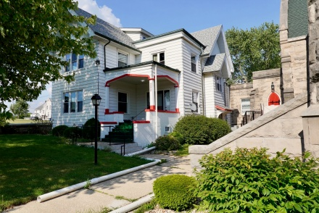
The rectory is a home for our clergy. The rectory was established around the same time as the church, and has served as a residence for a majority of our priests. This home includes multiple bedrooms, two bathrooms, a formal dining room, comfortable living room, eat-in kitchen, and a basement. While the rectory has been updated over the years, the congregation remains dedicated to continuing thoughtful upgrades to support clergy and preserve its charm.

Our Congregation

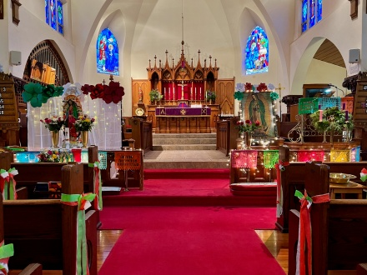
St. Paul’s Episcopal Church is deeply blessed to be a place of peace and unity. We are free from internal strife and open our doors—and our hearts—to all who seek spiritual connection. Over the past 10 years, our parish has joyfully embraced a blending of cultures, creating a vibrant and inclusive environment. Celebrations such as the Feast of Our Lady of Guadalupe and Quinceañeras have become cherished traditions, enriching our shared spiritual life.

St. Paul’s is a small but highly active parish, where lay members from both cultures work together in worship, service, and fellowship. Our shared goal is to build bridges between cultures, and fostering unity through faith. Highlights of our lay involvement include altar guild, fellowship hosts, vestry members, Eucharistic ministers, and lay ministers who lead Morning Prayer on occasion.

There is a strong and enduring sense of community at St. Paul’s. Parishioners generously share their time, talents, and resources to support one another, respond to needs in Kankakee County and beyond, and engage in the many ministries that define our church’s mission.

Our Music Ministry uplifts the soul, inspiring all who gather through rich and meaningful hymns and liturgical music. The music ministry is directed by our Choir Master and music provided by our organist.

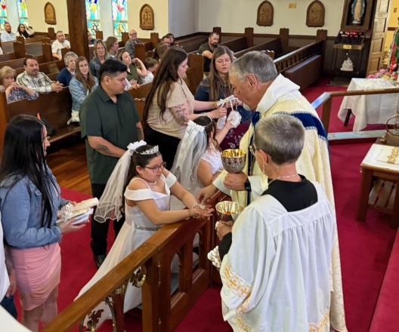
Youth ministry is a vital and growing part of life at St. Paul’s. We are committed to reinvigorating our programs and deepening engagement with young parishioners. It is our goal to broaden and engage our youth to serve as acolytes and torch bearers.

We are blessed to provide Sunday school for our youth and have a devoted teacher that volunteers their time and service to the instruction not only for school but also confirmation and first communion. Our dedication to nurturing the faith and leadership of young people has been a key driver of parish growth, and we remain committed to expanding this ministry with joy and purpose.

Our Community

Kankakee, Illinois, lies about 60 miles south of Chicago along the Kankakee River. With a population of around 25,000, it serves as the county seat of Kankakee County. The city is often called the “City on the River” due to its picturesque location.

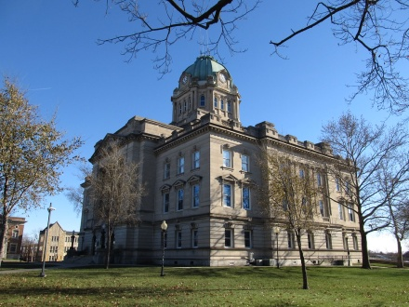
In 2023, Kankakee County, IL had a population of 107,000 people with a median age of 39 and a median household income of $68,325. Between 2022 and 2023 the population of Kankakee County, IL declined a bit. The 5 largest ethnic groups in Kankakee County, IL are White (Non-Hispanic), Black or African American (Non-Hispanic), White (Hispanic), Other (Hispanic), and Two Races Including Other (Hispanic). The largest universities in Kankakee County, IL are Olivet Nazarene University (1,004 degrees awarded in 2023) and Kankakee Community College (682 degrees).

The geography of Kankakee includes rich farmland, rolling prairies, and a network of rivers and streams. The Kankakee River provides scenic beauty and has played a central role in the city’s history. Its proximity to Chicago makes it a convenient and appealing location.

Kankakee is known for its historical significance and architecture. The B. Harley Bradley House, designed by Frank Lloyd Wright, is a major attraction. The Kankakee River State Park offers beautiful natural surroundings and highlights the city’s connection to the river.


Unique features include its vibrant arts community and strong cultural traditions. Kankakee is also known for hosting local festivals that celebrate its history and bring residents together. Such as Kankakee Farmer’s Market, Kankakee County Fair, Merchant Street Fest, Kankakee Symphony Orchestra. It has a rich industrial past and continues to grow as a hub for small businesses and community innovation.

Kankakee blends small-town charm with historical and cultural richness, making it a noteworthy part of Illinois.

Stewardship

As we look to the future of St. Paul’s, it’s essential to recognize the importance of stewardship—not only in sustaining our ministries, but in nurturing the spiritual and communal life of our parish. We are called to be faithful stewards of the resources God has entrusted to us, and to invite others into the life-giving work of our church.

We are committed to welcoming new members, deepening relationships with current parishioners, and expanding our presence in the wider community.

We must also take an honest look at our financial health. To support our mission of financial health, we will need to continue to organize stewardship campaigns that encourage generous and joyful giving, educate parishioners about the church’s financial needs, and celebrate the impact of every contribution. Through transparency, shared responsibility, and faithful commitment we can ensure that St. Paul’s remains a thriving spiritual home for generations to come.

2025 Annual Budget
St. Paul’s Episcopal Church

Income Budget

Income, Unrestricted 104,650

Asset Earnings & Unrestricted Gifts 13,000

Fundraising 5,250

Total Income $122,900

Expense Budget

General Administration
Insurance 27,371
Office Expense 9,360

Total General Administration 36,731

Facilities & Equipment
Church 15,195
Rectory 4,100

Total Facilities and Equipment 19,295

Personnel
Rector 87,019
Organist 7,846
Choirmaster 5,417

Total Personnel 100,282

Ministry
Worship 1,400
Education/Youth/Evangelism 4,200
Stewardship 120

Total Ministry 5,720

Total Outside Giving 7,600

Total Expenses $169,628

Our Rector

St. Paul’s Episcopal Church, located in the heart of downtown Kankakee, Illinois, is a welcoming and inclusive parish rooted in love, tradition, and community. We are prayerfully seeking a faithful pastor—a person of integrity and deep spirituality—who will care for God’s people at St. Paul’s and equip us to live out our ministries with purpose and joy.

We seek a rector who embraces and celebrates Latino culture. Bilingual fluency or prior experience with Spanish-speaking communities would be a tremendous asset, but not a requirement. At the same time, we remain committed to supporting our non-Hispanic members, many of whom would benefit from regular pastoral visits—especially those in assisted living or homebound.

We are eager to expand Christian education opportunities throughout the week, guided by our priest and supported by lay leaders. Continued leadership in membership growth, youth engagement, and community outreach is essential. A strong foundation in liturgy will also be invaluable as we deepen our program of bilingual worship, honoring both our heritage and our evolving identity as a parish family.

We invite the movement of the Holy Spirit to guide our search toward a person who embodies the following qualities:

- Genuine, compassionate, welcoming, and hospitable servant leader who enables us to connect with God through scripture, music, and traditional and contemporary forms of worship.
- A leader with collaborative, administrative, and supervisory skills, who practices participatory and transparent decision-making, and empowers individuals.
- A compassionate spiritual leader who embodies God’s grace through empathetic support, serving all people—regardless of sexual orientation or background—with dignity and care, especially in times of need.
- A leading light in evangelism and mission beyond St. Paul’s doors.
- Teacher, inspirer, nurturer, and supporter of practices of stewardship, generosity, and gratitude.

We look forward to weaving together our vision for St. Paul’s future with the gifts and passions of our next rector. Together, we will chart a course of mission, renewal, and joyful service—guided by grace, grounded in tradition, and open to the Spirit’s leading.

For More Information – How to Apply

To apply for this position, please complete The Clergy Information Form for Transitions from the Diocesan website: episcopalchicago.wufoo.com/forms/m1poxgz40cwsj2w/

Questions about this position should be directed to The Reverend Canon Andrea Mysen, Canon to the Ordinary: amysen@episcopalchicago.org.

Website: episcopalkankakee.org

Please look us up on Facebook

